Chapter 2

Self-Review Exercises
2.1 Fill in the blanks in each of the following statements:

a) A(n)___left brace_____ begins the body of every method, and a(n)____right brace____ ends the body of every method.
b) You can use the _____if____ statement to make decisions.
c) _____//____begins an end-of-line comment.
d)___Blank_____ , ____tabs____and ____newlines____are called white space.
e) ____keywords_____ are reserved for use by Java.
f) Java applications begin execution at method ____main____ .
g) Methods____System.out.print____ ,___System.out.println____ and___System.out.printf___ display information in a command window.

2.2 State whether each of the following is true or false. If false, explain why.
a) Comments cause the computer to print the text after the // on the screen when the program executes. FALSE. Comments do not cause the computer to print text on the screen; they are ignored by the Java compiler and are used solely to document code for humans.
b) All variables must be given a type when they’re declared. TRUE.
c) Java considers the variables number and NuMbEr to be identical. FALSE . Java is case-sensitive, so number and NuMbEr are entirely distinct identifiers.
d) The remainder operator (%) can be used only with integer operands. FALSE. The remainder operator (%) can be used with both integer and floating-point types in Java. The remainder operator (%) can be used with both integer and floating-point types in Java.
e) The arithmetic operators *, /, %, + and - all have the same level of precedence. FALSE. The multiplicative operators (*, /, %) have a higher level of precedence than the additive operators (+, -).

2.3 Write statements to accomplish each of the following tasks:
a) Declare variables c, thisIsAVariable, q76354 and number to be of type int.
ANSWER: int c, thisIsAVariable, q76354, number;
b) Prompt the user to enter an integer.
ANSWER: System.out.print("Enter an integer: ");
c) Input an integer and assign the result to int variable value. Assume Scanner variable input can be used to read a value from the keyboard.
ANSWER: value = input.nextInt();
d) Print "This is a Java program" on one line in the command window. Use method System.out.println.
ANSWER: System.out.println("This is a Java program");
e) Print "This is a Java program" on two lines in the command window. The first line should end with Java. Use method System.out.printf and two %s format specifiers.
ANSWER: System.out.printf("%s%n%s%n", "This is a Java", "program");
f) If the variable number is not equal to 7, display "The variable number is not equal to 7”
ANSWER: if (number != 7) {
System.out.println("The variable number is not equal to 7");
}

2.4 Identify and correct the errors in each of the following statements:
a) if (c < 7); System.out.println("c is less than 7");
ANSWER: Error: There is a semicolon right after the if condition closing parenthesis, which acts as an empty statement and separates the condition from the execution body. CORRECTION: REMOVE THE SEMICOLON if (c < 7)
System.out.println("c is less than 7");
b) if (c => 7) System.out.println("c is equal to or greater than 7");
ANSWER: ) Error: The relational operator => is incorrect. CORRECTION: CHANGE => TO >=
if (c >= 7)
System.out.println("c is equal to or greater than 7");

2.5 Write declarations, statements or comments that accomplish each of the following tasks:
a) State that a program will calculate the product of three integers.
ANSWER: // A program that calculates the product of three integers.
b) Create a Scanner called input that reads values from the standard input.
ANSWER: Scanner input = new Scanner(System.in);
c) Declare the variables x, y, z and result to be of type int.
ANSWER: int x, y, z, result;
d) Prompt the user to enter the first integer.
ANSWER: System.out.print("Enter first integer: ");
e) Read the first integer from the user and store it in the variable x.
ANSWER: x = input.nextInt();
f) Prompt the user to enter the second integer.
ANSWER: System.out.print("Enter second integer: ");
g) Read the second integer from the user and store it in the variable y.
ANSWER: y = input.nextInt();
h) Prompt the user to enter the third integer.
ANSWER: System.out.print("Enter third integer: ");
i) Read the third integer from the user and store it in the variable z.
ANSWER: z = input.nextInt();
j) Compute the product of the three integers contained in variables x, y and z, and assign the result to the variable result.
ANSWER: result = x * y * z;
k) Use System.out.printf to display the message "Product is" followed by the value of the variable result.
ANSWER: System.out.printf("Product is %d%n", result);

2.6 Using the statements you wrote in Exercise 2.5, write a complete program that calculates and prints the product of three integers.
ANSWER: import java.util.Scanner; // program uses class Scanner

public class Product {
public static void main(String[] args) {
// create Scanner to obtain input from command window
Scanner input = new Scanner(System.in);

int x; // first number input by user
int y; // second number input by user
int z; // third number input by user
int result; // product of numbers

System.out.print("Enter first integer: "); // prompt
x = input.nextInt(); // read first integer

System.out.print("Enter second integer: "); // prompt
y = input.nextInt(); // read second integer

System.out.print("Enter third integer: "); // prompt
z = input.nextInt(); // read third integer

result = x * y * z; // calculate product of numbers

System.out.printf("Product is %d%n", result);
} // end method main
} // end class Product

Exercises
2.7 Fill in the blanks in each of the following statements:
a) ____comments___ are used to document a program and improve its readability.
b) A decision can be made in a Java program with a(n)____statement _____ .
c) Calculations are normally performed by ____assignment___ statements.
d) The arithmetic operators with the same precedence as multiplication are ____division____ and ____remainder_____ .
e) When parentheses in an arithmetic expression are nested, the ___innermost____ set of parentheses is evaluated first.
f) A location in the computer’s memory that may contain different values at various times throughout the execution of a program is called a(n) __variable__.
2.8 Write Java statements that accomplish each of the following tasks: a) Display the message "Enter an integer: ", leaving the cursor on the same line.
ANSWER: System.out.print("Enter an integer: ");
b) Assign the product of variables b and c to variable a.
ANSWER: A = B * C;
c) Use a comment to state that a program performs a sample payroll calculation.
ANSWER: // This program performs a sample payroll calculation.
2.9 State whether each of the following is true or false. If false, explain why.
a) Java operators are evaluated from left to right. FALSE
b) The following are all valid variable names: _under_bar_, m928134, t5, j7, her_sales$, his_$account_total, a, b$, c, z and z2.
TRUE
c) A valid Java arithmetic expression with no parentheses is evaluated from left to right. TRUE
d) The following are all invalid variable names: 3g, 87, 67h2, h22 and 2h. FALSE
2.10 Assuming that x=2 and y=3, what does each of the following statements display?
a) System.out.printf("x = %d%n", x);
ANSWER: ```text
x = 2
b) System.out.printf("Value of %d + %d is %d%n", x, x, (x + x));
ANSWER: ```text
Value of 2 + 2 is 4

c) System.out.printf("x =");
ANSWER: ``` text
x =

d) System.out.printf("%d = %d%n", (x + y), (y + x));
ANSWER: ```text
5 = 5
2.11 Which of the following Java statements contain variables whose values are modified?
a) p=i+j+k+ 7;
ANSWER: p = i + j + k + 7; — Modified. The assignment operator (=) stores a new value in the variable p.

b) System.out.println("variables whose values are modified");
ANSWER: System.out.println("variables whose values are modified"); — Not modified. This statement only prints a literal string to the command window.
c) System.out.println("a = 5");
ANSWER: System.out.println("a = 5"); — Not modified. This prints a literal string; no variables are involved or changed.
d) value = input.nextInt();
ANSWER: value = input.nextInt(); — Modified. The assignment operator (=) takes the input read from the keyboard and stores it in the variable value.
2.12 Given that y = ax3 + 7, which of the following are correct Java statements for this equation?
a) y=a*x*x*x+ 7; COEERCT
b) y = a * x * x * (x + 7); INCORRECT
c) y = (a * x) * x * (x + 7); INCORRECT
d) y = (a * x) * x * x + 7; CORRECT
e) y = a * (x * x * x) + 7; CORRECT
f) y = a * x * (x * x + 7); INCORRECT

2.13 State the order of evaluation of the operators in each of the following Java statements, and show the value of x after each statement is performed:
a) x = 7 + 3 * 6 / 2 - 1;
ANSWER: x = 7 + 3 * 6 / 2 - 1;
Order of evaluation: 1.) 3 * 6 (Multiplication has higher precedence than addition/subtraction) \rightarrow 18
2.) 18 / 2 (Division has same precedence as multiplication, evaluated left-to-right) \rightarrow 9
3.) 7 + 9 (Addition evaluated left-to-right) \rightarrow 16
4.) 16 - 1 (Subtraction evaluated left-to-right) \rightarrow 15
5.) = (Assignment)
Value of x: 15
b) x = 2 % 2 + 2 * 2 - 2 / 2;
ANSWER: x = 2 % 2 + 2 * 2 - 2 / 2;
Order of evaluation:
- 2 % 2 (Remainder, evaluated left-to-right) \rightarrow 0
- 2 * 2 (Multiplication, evaluated left-to-right) \rightarrow 4
3.) 2 / 2 (Division, evaluated left-to-right) \rightarrow 1
4.) 0 + 4 (Addition, evaluated left-to-right) \rightarrow 4
5.) 4 - 1 (Subtraction) \rightarrow 3
6.) = (Assignment)
Value of x: 3
c) x=(3 * 9 * (3 + (9 * 3 / (3))));
ANSWER: x = (3 * 9 * (3 + (9 * 3 / (3))));
Order of evaluation:
- (3) (Innermost parentheses evaluated first) \rightarrow 3
- 9 * 3 (Multiplication inside the next inner layer) \rightarrow 27
- 27 / 3 (Division inside that same layer) \rightarrow 9
- 3 + 9 (Addition inside the outer parenthetical layer) \rightarrow 12
- 3 * 9 (Multiplication outside, evaluated left-to-right) \rightarrow 27
- 27 * 12 (Final multiplication within the full parenthetical block) \rightarrow 324
- = (Assignment)
Value of x: 324

2.14 Write an application that displays the numbers 1 to 4 on the same line, with each pair of adjacent numbers separated by one space. Use the following techniques:
a) Use one System.out.println statement.
b) Use four System.out.print statements.
c) Use one System.out.printf statement. www.EBooksWorld.ir 68 Chapter 2 Introduction to Java Applications; Input/Output and Operators
ANSWER:
public class DisplayNumbers {
public static void main(String[] args) {
// a) Using one System.out.println statement
System.out.println("1 2 3 4");

// b) Using four System.out.print statements
System.out.print("1 ");
System.out.print("2 ");
System.out.print("3 ");
System.out.print("4\n"); // added newline to separate next output

// c) Using one System.out.printf statement
System.out.printf("%d %d %d %d%n", 1, 2, 3, 4);
}
}
2.15 (Arithmetic) Write an application that asks the user to enter two integers, obtains them from the user and prints their sum, product, difference and quotient (division). Use the techniques shown in Fig. 2.7.
ANSWER:
import java.util.Scanner;

public class Arithmetic {
public static void main(String[] args) {
Scanner input = new Scanner(System.in);

System.out.print("Enter first integer: ");
int num1 = input.nextInt();

System.out.print("Enter second integer: ");
int num2 = input.nextInt();

int sum = num1 + num2;
int product = num1 * num2;
int difference = num1 - num2;
int quotient = num1 / num2;

System.arraycontents...
System.out.printf("Sum = %d%n", sum);
System.out.printf("Product = %d%n", product);
System.out.printf("Difference = %d%n", difference);
System.out.printf("Quotient = %d%n", quotient);
}
}
2.16 (Comparing Integers) Write an application that asks the user to enter two integers, obtains them from the user and displays the larger number followed by the words "is larger". If the numbers are equal, print the message "These numbers are equal". Use the techniques shown in Fig.
ANSWER:
import java.util.Scanner;

public class Comparison {
public static void main(String[] args) {
Scanner input = new Scanner(System.in);

System.out.print("Enter first integer: ");
int num1 = input.nextInt();

System.out.print("Enter second integer: ");
int num2 = input.nextInt();

if (num1 > num2) {
System.out.printf("%d is larger%n", num1);
}

if (num2 > num1) {
System.out.printf("%d is larger%n", num2);
}

if (num1 == num2) {
System.out.println("These numbers are equal");
}
}
}
2.15. 2.17 (Arithmetic, Smallest and Largest) Write an application that inputs three integers from the user and displays the sum, average, product, smallest and largest of the numbers. Use the techniques shown in Fig. 2.15. [Note: The calculation of the average in this exercise should result in an integer representation of the average. So, if the sum of the values is 7, the average should be 2, not 2.3333….]
ANSWER:
import java.util.Scanner;

public class ThreeIntegerArithmetic {
public static void main(String[] args) {
Scanner input = new Scanner(System.in);

System.out.print("Enter first integer: ");
int num1 = input.nextInt();

System.out.print("Enter second integer: ");
int num2 = input.nextInt();

System.out.print("Enter third integer: ");
int num3 = input.nextInt();

int sum = num1 + num2 + num3;
int average = sum / 3; // Integer division truncated automatically
int product = num1 * num2 * num3;

// Determine smallest
int smallest = num1;
if (num2 < smallest) smallest = num2;
if (num3 < smallest) smallest = num3;

// Determine largest
int largest = num1;
if (num2 > largest) largest = num2;
if (num3 > largest) largest = num3;

System.out.printf("Sum = %d%n", sum);
System.out.printf("Average = %d%n", average);
System.out.printf("Product = %d%n", product);
System.out.printf("Smallest = %d%n", smallest);
System.out.printf("Largest = %d%n", largest);
}
}
2.18 (Displaying Shapes with Asterisks) Write an application that displays a box, an oval, an arrow and a diamond using asterisks (*), as follows:
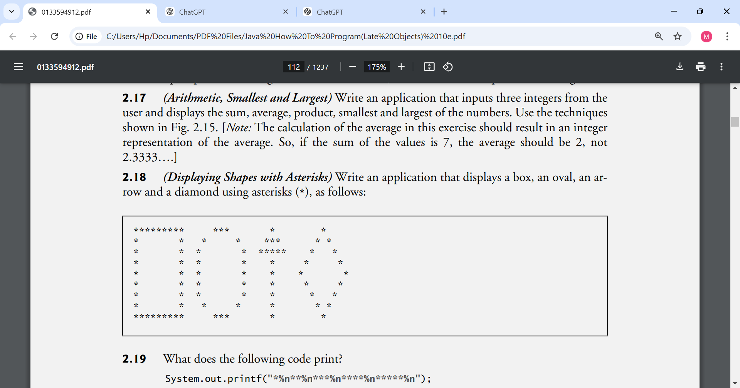
ANSWER:
public class Shapes {
public static void main(String[] args) {
System.out.println("********* *** * *");
System.out.println("* * * * *** * *");
System.out.println("* * * * ***** * *");
System.out.println("* * * * * * *");
System.out.println("* * * * * * *");
System.out.println("* * * * * * *");
System.out.println("* * * * * * *");
System.out.println("* * * * * * *");
System.out.println("********* *** * *");
}
}
2.19 What does the following code print? System.out.printf("*%n**%n***%n****%n*****%n");
ANSWER:
*
**
***
****
*****
2.20 What does the following code print?
System.out.println("*"); System.out.println("***"); System.out.println("*****");
System.out.println("****");
System.out.println("**");
ANSWER:
The code uses sequential println calls, which add a newline after every execution:
*
***
*****
****
**
2.21 What does the following code print?
System.out.print("*"); System.out.print("***");
System.out.print("*****");
System.out.print("****");
System.out.println("**");
ANSWER:
The code uses sequential print statements (which do not move the cursor to a new line) and finishes with a single println:
Text

2.22 What does the following code print?
System.out.print("*");
System.out.println("***");
System.out.println("*****");
System.out.print("****");
System.out.println("**");
ANSWER:
The code uses a mix of print and println statements:
Text
****
*****
******

2.23 What does the following code print? System.out.printf("%s%n%s%n%s%n", "*", "***", "*****");
ANSWER:
The format string code uses three %s string placeholders and three newline format specifiers (%n) to structure the output:
*
***
*****
2.24 (Largest and Smallest Integers) Write an application that reads five integers and determines and prints the largest and smallest integers in the group. Use only the programming techniques you learned in this chapter.
ANSWER:
import java.util.Scanner;

public class LargestSmallest {
public static void main(String[] args) {
Scanner input = new Scanner(System.in);

// Read five integers from the user
System.out.print("Enter first integer: ");
int num1 = input.nextInt();

System.out.print("Enter second integer: ");
int num2 = input.nextInt();

System.out.print("Enter third integer: ");
int num3 = input.nextInt();

System.out.print("Enter fourth integer: ");
int num4 = input.nextInt();

System.out.print("Enter fifth integer: ");
int num5 = input.nextInt();

// Assume the first number is both the largest and smallest initially
int largest = num1;
int smallest = num1;

// Determine the largest value
if (num2 > largest) {
largest = num2;
}
if (num3 > largest) {
largest = num3;
}
if (num4 > largest) {
largest = num4;
}
if (num5 > largest) {
largest = num5;
}

// Determine the smallest value
if (num2 < smallest) {
smallest = num2;
}
if (num3 < smallest) {
smallest = num3;
}
if (num4 < smallest) {
smallest = num4;
}
if (num5 < smallest) {
smallest = num5;
}

// Display results
System.arraycontents...
System.out.printf("Largest integer is: %d%n", largest);
System.out.printf("Smallest integer is: %d%n", smallest);
}
}
2.25 (Odd or Even) Write an application that reads an integer and determines and prints whether it’s odd or even. [Hint: Use the remainder operator. An even number is a multiple of 2. Any multiple of 2 leaves a remainder of 0 when divided by 2.]
ANSWER:
import java.util.Scanner;

public class OddOrEven {
public static void main(String[] args) {
Scanner input = new Scanner(System.in);

// Read an integer from the user
System.out.print("Enter an integer: ");
int number = input.nextInt();

// Determine if the number is even or odd
if (number % 2 == 0) {
System.arraycontents...
System.out.printf("%d is even%n", number);
}

if (number % 2 != 0) {
System.out.printf("%d is odd%n", number);
}
}
}
2.26 (Multiples) Write an application that reads two integers, determines whether the first is a multiple of the second and prints the result. [Hint: Use the remainder operator.]
ANSWER:
import java.util.Scanner;

public class Multiples {
public static void main(String[] args) {
Scanner input = new Scanner(System.in);

// Read two integers from the user
System.out.print("Enter first integer: ");
int num1 = input.nextInt();

System.out.print("Enter second integer: ");
int num2 = input.nextInt();

// Determine if the first is a multiple of the second
if (num1 % num2 == 0) {
System.out.printf("%d is a multiple of %d%n", num1, num2);
}

if (num1 % num2 != 0) {
System.out.printf("%d is not a multiple of %d%n", num1, num2);
}
}
}
2.27 (Checkerboard Pattern of Asterisks) Write an application that displays a checkerboard pattern, as follows:
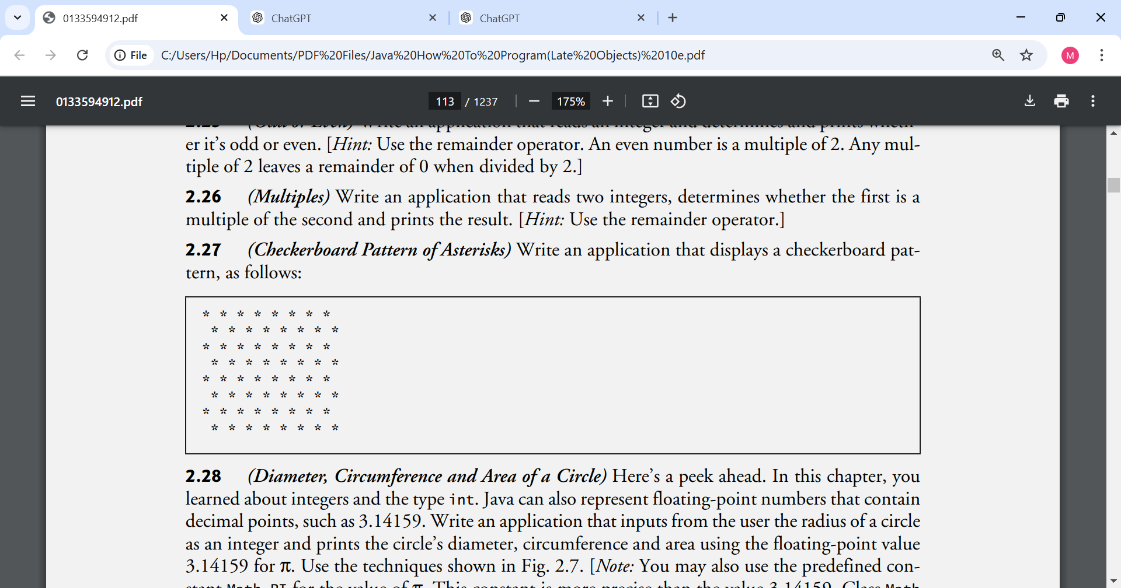
ANSWER:
public class Checkerboard {
public static void main(String[] args) {
System.out.println("* * * * * * * *");
System.out.println(" * * * * * * * *");
System.out.println("* * * * * * * *");
System.out.println(" * * * * * * * *");
System.out.println("* * * * * * * *");
System.out.println(" * * * * * * * *");
System.out.println("* * * * * * * *");
System.out.println(" * * * * * * * *");
}
}
2.28 (Diameter, Circumference and Area of a Circle) Here’s a peek ahead. In this chapter, you learned about integers and the type int. Java can also represent floating-point numbers that contain decimal points, such as 3.14159. Write an application that inputs from the user the radius of a circle as an integer and prints the circle’s diameter, circumference and area using the floating-point value 3.14159 for π. Use the techniques shown in Fig. 2.7. [Note: You may also use the predefined constant Math.PI for the value of π. This constant is more precise than the value 3.14159. Class Math is defined in package java.lang. Classes in that package are imported automatically, so you do not need to import class Math to use it.] Use the following formulas (r is the radius): diameter = 2r circumference = 2πr area = πr2 Do not store the results of each calculation in a variable. Rather, specify each calculation as the value that will be output in a System.out.printf statement. The values produced by the circumference and area calculations are floating-point numbers. Such values can be output with the format specifier %f in a System.out.printf statement.
ANSWER:
import java.util.Scanner;

public class Circle {
public static void main(String[] args) {
Scanner input = new Scanner(System.in);

System.out.print("Enter circle radius (as an integer): ");
int radius = input.nextInt();

// Calculations are performed directly within the printf arguments
System.out.printf("Diameter = %d%n", (2 * radius));
System.out.printf("Circumference = %f%n", (2 * Math.PI * radius));
System.out.printf("Area = %f%n", (Math.PI * radius * radius));
}
}

2.29 (Integer Value of a Character) Here’s another peek ahead. In this chapter, you learned about integers and the type int. Java can also represent uppercase letters, lowercase letters and a considerable variety of special symbols. Every character has a corresponding integer representation. The set of characters a computer uses together with the corresponding integer representations for those characters is called that computer’s character set. You can indicate a character value in a program simply by enclosing that character in single quotes, as in 'A'. You can determine a character’s integer equivalent by preceding that character with (int), as in (int) 'A' An operator of this form is called a cast operator. (You’ll learn about cast operators in Chapter 3.) The following statement outputs a character and its integer equivalent: System.out.printf("The character %c has the value %d%n", 'A', ((int) 'A')); When the preceding statement executes, it displays the character A and the value 65 (from the Unicode® character set) as part of the string. The format specifier %c is a placeholder for a character (in this case, the character 'A'). Using statements similar to the one shown earlier in this exercise, write an application that displays the integer equivalents of some uppercase letters, lowercase letters, digits and special symbols. Display the integer equivalents of the following: ABCabc012$*+/ and the blank character.
ANSWER:
public class CharacterValues {
public static void main(String[] args) {
System.out.printf("The character %c has the value %d%n", 'A', ((int) 'A'));
System.out.printf("The character %c has the value %d%n", 'B', ((int) 'B'));
System.out.printf("The character %c has the value %d%n", 'C', ((int) 'C'));
System.out.printf("The character %c has the value %d%n", 'a', ((int) 'a'));
System.out.printf("The character %c has the value %d%n", 'b', ((int) 'b'));
System.out.printf("The character %c has the value %d%n", 'c', ((int) 'c'));
System.out.printf("The character %c has the value %d%n", '0', ((int) '0'));
System.out.printf("The character %c has the value %d%n", '1', ((int) '1'));
System.out.printf("The character %c has the value %d%n", '2', ((int) '2'));
System.out.printf("The character %c has the value %d%n", '$', ((int) '$'));
System.out.printf("The character %c has the value %d%n", '*', ((int) '*'));
System.out.printf("The character %c has the value %d%n", '+', ((int) '+'));
System.out.printf("The character %c has the value %d%
2.30 (Separating the Digits in an Integer) Write an application that inputs one number consisting of five digits from the user, separates the number into its individual digits and prints the digits separated from one another by three spaces each. For example, if the user types in the number 42339, the program should print
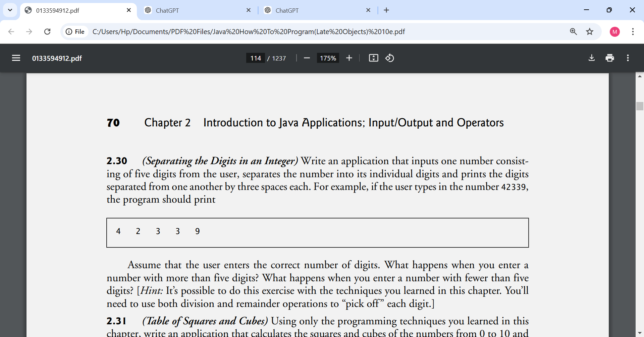

Assume that the user enters the correct number of digits. What happens when you enter a number with more than five digits? What happens when you enter a number with fewer than five digits? [Hint: It’s possible to do this exercise with the techniques you learned in this chapter. You’ll need to use both division and remainder operations to “pick off ” each digit.]
ANSWER:
import java.util.Scanner;

public class Digits {
public static void main(String[] args) {
Scanner input = new Scanner(System.in);

System.out.print("Enter a five-digit integer: ");
int number = input.nextInt();

// Break down the number using division and remainder operators
int digit1 = number / 10000;
int remainder = number % 10000;

int digit2 = remainder / 1000;
remainder = remainder % 1000;

int digit3 = remainder / 100;
remainder = remainder % 100;

int digit4 = remainder / 10;
int digit5 = remainder % 10;

// Print the digits separated by three spaces each
System.out.printf("%d %d %d %d %d%n", digit1, digit2, digit3, digit4, digit5);
}
}

2.31 (Table of Squares and Cubes) Using only the programming techniques you learned in this chapter, write an application that calculates the squares and cubes of the numbers from 0 to 10 and prints the resulting values in table format, as shown below.
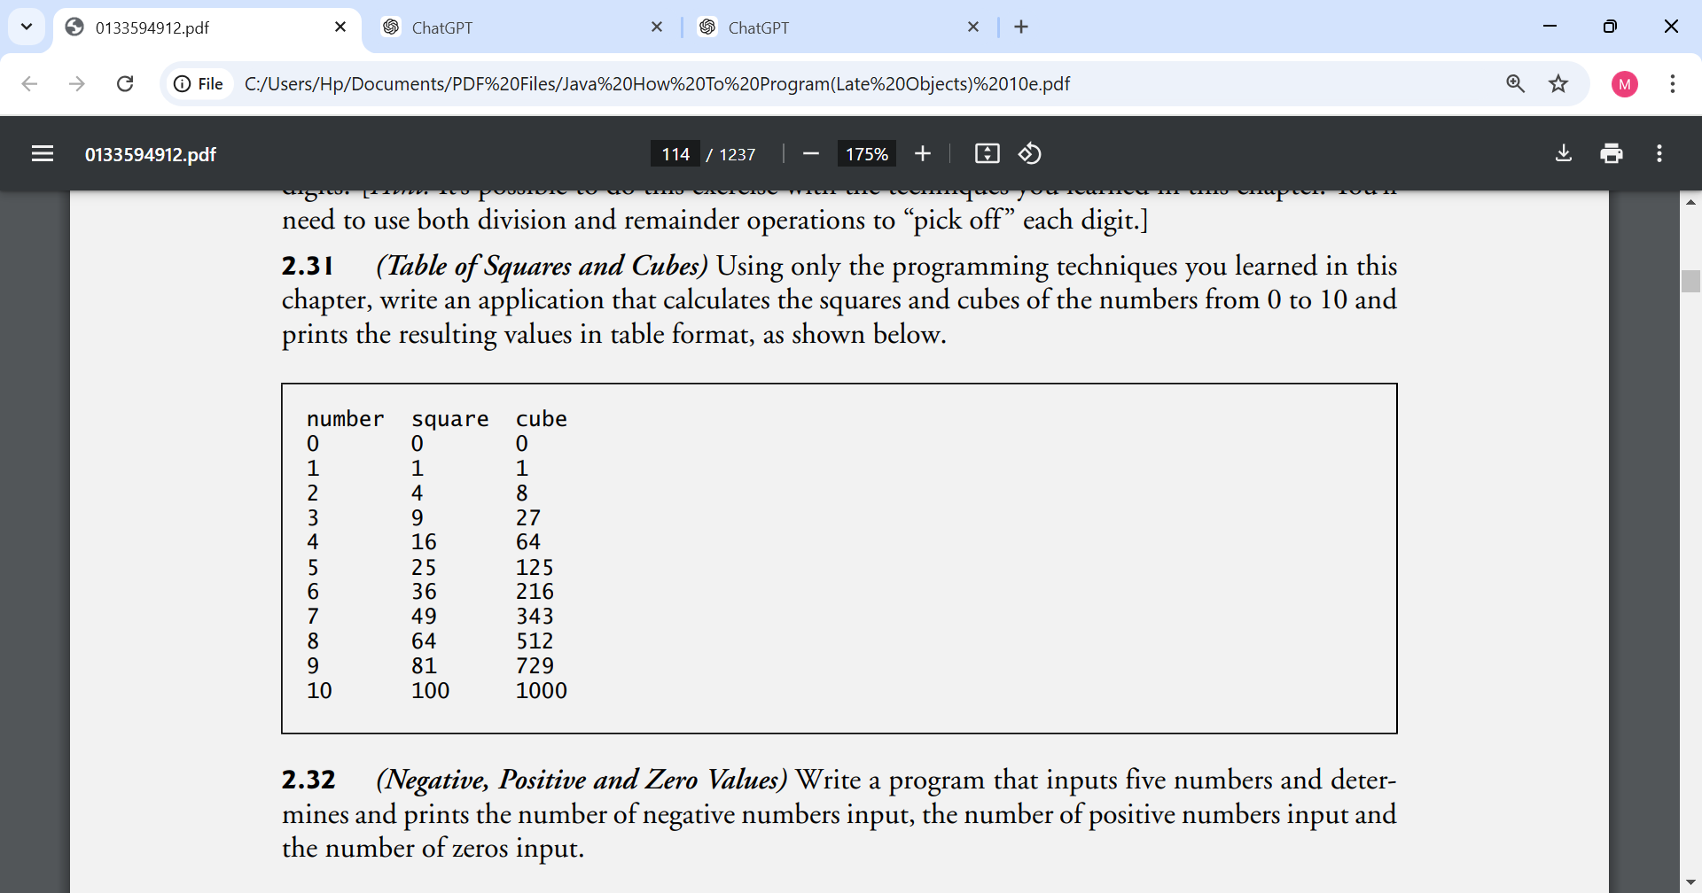
ANSWER:
public class Table {
public static void main(String[] args) {
// Print the table header
System.out.printf("%s\t%s\t%s%n", "number",
2.32 (Negative, Positive and Zero Values) Write a program that inputs five numbers and determines and prints the number of negative numbers input, the number of positive numbers input and the number of zeros input.
ANSWERS:
import java.util.Scanner;

public class NumberCounter {
public static void main(String[] args) {
Scanner input = new Scanner(System.in);

// Read five numbers from the user
System.out.print("Enter first integer: ");
int num1 = input.nextInt();

System.out.print("Enter second integer: ");
int num2 = input.nextInt();

System.out.print("Enter third integer: ");
int num3 = input.nextInt();

System.out.print("Enter fourth integer: ");
int num4 = input.nextInt();

System.out.print("Enter fifth integer: ");
int num5 = input.nextInt();

// Initialize counters for negative, positive, and zero values
int negativeCount = 0;
int positiveCount = 0;
int zeroCount = 0;

// Evaluate the first number
if (num1 < 0) {
negativeCount = negativeCount + 1;
}
if (num1 > 0) {
positiveCount = positiveCount + 1;
}
if (num1 == 0) {
zeroCount = zeroCount + 1;
}

// Evaluate the second number
if (num2 < 0) {
negativeCount = negativeCount + 1;
}
if (num2 > 0) {
positiveCount = positiveCount + 1;
}
if (num2 == 0) {
zeroCount = zeroCount + 1;
}

// Evaluate the third number
if (num3 < 0) {
negativeCount = negativeCount + 1;
}
if (num3 > 0) {
positiveCount = positiveCount + 1;
}
if (num3 == 0) {
zeroCount = zeroCount + 1;
}

// Evaluate the fourth number
if (num4 < 0) {
negativeCount = negativeCount + 1;
}
if (num4 > 0) {
positiveCount = positiveCount + 1;
}
if (num4 == 0) {
zeroCount = zeroCount + 1;
}

// Evaluate the fifth number
if (num5 < 0) {
negativeCount = negativeCount + 1;
}
if (num5 > 0) {
positiveCount = positiveCount + 1;
}
if (num5 == 0) {
zeroCount = zeroCount + 1;
}

// Display the results
System.out.printf("%nTotal negative numbers: %d%n", negativeCount);
System.out.printf("Total positive numbers: %d%n", positiveCount);
System.out.printf("Total zeros: %d%n", zeroCount);
}
}

Making a Difference
2.33 (Body Mass Index Calculator) We introduced the body mass index (BMI) calculator in Exercise 1.10. The formulas for calculating BMI are
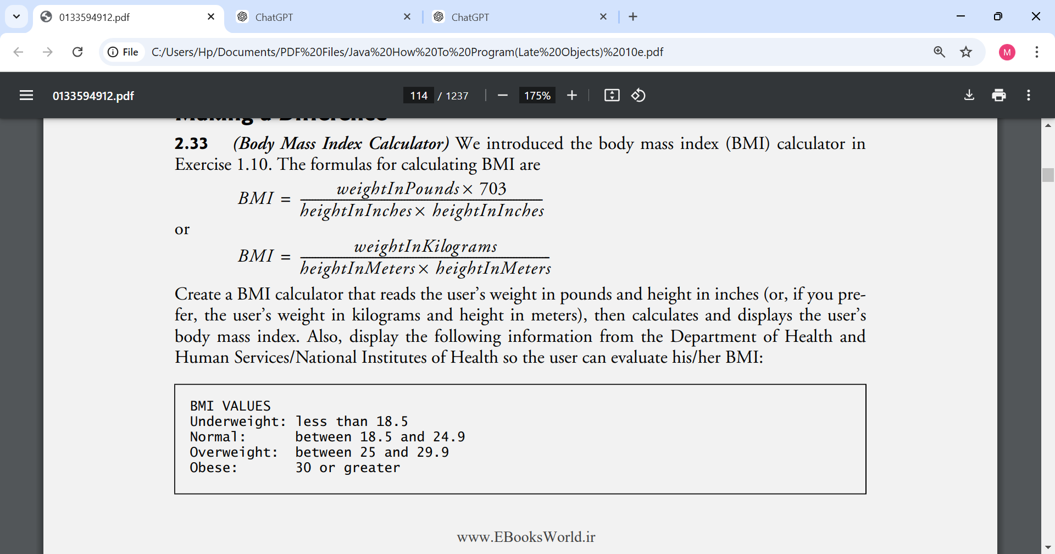
Create a BMI calculator that reads the user’s weight in pounds and height in inches (or, if you prefer, the user’s weight in kilograms and height in meters), then calculates and displays the user’s body mass index. Also, display the following information from the Department of Health and Human Services/National Institutes of Health so the user can evaluate his/her BMI:

[Note: In this chapter, you learned to use the int type to represent whole numbers. The BMI calculations when done with int values will both produce whole-number results. In Chapter 3, you’ll learn to use the double type to represent numbers with decimal points. When the BMI calculations are performed with doubles, they’ll both produce numbers with decimal points—these are called “floating-point” numbers.]
ANSWER:
import java.util.Scanner;

public class BMICalculator {
public static void main(String[] args) {
Scanner input = new Scanner(System.in);

// Prompt the user to select an input system
System.out.println("Choose your input units:");
System.out.println("1 - English Units (Weight in pounds, Height in inches)");
System.out.println("2 - Metric Units (Weight in kilograms, Height in meters)");
System.out.print("Enter choice (1 or 2): ");
int choice = input.nextInt();

int bmi = 0;

if (choice == 1) {
// English Formula: BMI = (weightInPounds * 703) / (heightInInches * heightInInches)
System.out.print("Enter weight in pounds: ");
int weightInPounds = input.nextInt();

System.out.print("Enter height in inches: ");
int heightInInches = input.nextInt();

bmi = (weightInPounds * 703) / (heightInInches * heightInInches);
}

if (choice == 2) {
// Metric Formula: BMI = weightInKilograms / (heightInMeters * heightInMeters)
System.out.print("Enter weight in kilograms: ");
int weightInKilograms = input.nextInt();

System.out.print("Enter height in meters: ");
int heightInMeters = input.nextInt();

bmi = weightInKilograms / (heightInMeters * heightInMeters);
}

// Display the calculated BMI result
System.out.printf("%nYour calculated Body Mass Index (BMI) is: %d%n%n", bmi);

// Display the reference evaluation information
System.out.println("BMI VALUES");
System.out.println("Underweight: less than 18.5");
System.out.println("Normal: between 18.5 and 24.9");
System.out.println("Overweight: between 25 and 29.9");
System.out.println("Obese: 30 or greater");
}
}

2.34 (World Population Growth Calculator) Use the web to determine the current world population and the annual world population growth rate. Write an application that inputs these values, then displays the estimated world population after one, two, three, four and five years.
ANSWER:
import java.util.Scanner;

public class PopulationCalculator {
public static void main(String[] args) {
Scanner input = new Scanner(System.in);

// Prompt user for current world population and annual growth rate
System.out.print("Enter the current world population: ");
long currentPopulation = input.nextLong();

System.out.print("Enter the annual growth rate (e.g., 0.0085 for 0.85%): ");
double growthRate = input.nextDouble();

// Year 1 calculation
long year1Increase = (long) (currentPopulation * growthRate);
long populationYear1 = currentPopulation + year1Increase;

// Year 2 calculation
long year2Increase = (long) (populationYear1 * growthRate);
long populationYear2 = populationYear1 + year2Increase;

// Year 3 calculation
long year3Increase = (long) (populationYear2 * growthRate);
long populationYear3 = populationYear2 + year3Increase;

// Year 4 calculation
long year4Increase = (long) (populationYear3 * growthRate);
long populationYear4 = populationYear3 + year4Increase;

// Year 5 calculation
long year5Increase = (long) (populationYear4 * growthRate);
long populationYear5 = populationYear4 + year5Increase;

// Display results
System.out.printf("%nEstimated World Population Results:%n");
System.out.printf("After 1 Year: %d%n", populationYear1);
System.out.printf("After 2 Years: %d%n", populationYear2);
System.out.printf("After 3 Years: %d%n", populationYear3);
System.out.printf("After 4 Years: %d%n", populationYear4);
System.out.printf("After 5 Years: %d%n", populationYear5);
}
}

2.35 (Car-Pool Savings Calculator) Research several car-pooling websites. Create an application that calculates your daily driving cost, so that you can estimate how much money could be saved by carpooling, which also has other advantages such as reducing carbon emissions and reducing traffic congestion. The application should input the following information and display the user’s cost per day of driving to work:
a) Total miles driven per day.
b) Cost per gallon of gasoline.
c) Average miles per gallon.
d) Parking fees per day.
e) Tolls per day
ANSWER:
import java.util.Scanner;

public class CarPoolCalculator {
public static void main(String[] args) {
Scanner input = new Scanner(System.in);

// Input data from the user
System.out.print("Enter total miles driven per day: ");
int totalMiles = input.nextInt();

System.out.print("Enter cost per gallon of gasoline (in cents, e.g., 350 for $3.50): ");
int costPerGallon = input.nextInt();

System.out.print("Enter average miles per gallon: ");
int milesPerGallon = input.nextInt();

System.out.print("Enter parking fees per day (in cents): ");
int parkingFees = input.nextInt();

System.out.print("Enter tolls per day (in cents): ");
int tolls = input.nextInt();

// Calculate daily cost of gasoline
// (Total Miles / Miles Per Gallon) * Cost Per Gallon
int gasolineCost = (totalMiles / milesPerGallon) * costPerGallon;

// Calculate total daily driving cost
int totalDailyCost = gasolineCost + parkingFees + tolls;

// Convert the final cent values back into dollars and cents for display
int totalDollars = totalDailyCost / 100;
int totalCents = totalDailyCost % 100;

// Display the driving cost per day
System.out.printf("%nYour daily cost of driving to work is: $%d.%02d%n", totalDollars, totalCents);
System.out.println("Consider car-pooling to save money, reduce carbon emissions, and ease traffic congestion!");
}
}

